NAME: DONEL

SURNAME: NTAMBWE

STUDENT NUMBER: ST10434784

GROUP MEMBERS:

Elton Marumbwa ST10453820

Emmanuel Olafisoye ST10450437

Samuel Mogashoa ST10453678

**WIL SELF EVAULATION REFLECT REPORT.**

**Introduction**

Work-Integrated Learning (WIL) provides students with practical experience, bridging the gap between academic learning and real-world application. It allows for the development of industry-specific and transferable skills, preparing students for professional environments. For me, WIL was an opportunity to enhance my technical expertise while collaborating with a team to create functional and meaningful solutions.

**Skills**

During my WIL experience, I gained several skills across various categories:

**Industry-Specific Practices**

* **Web and Mobile Application Development:** Collaborated with my team to design and code websites and mobile applications. Tasks included UI/UX design, coding, debugging, and ensuring functionality met user requirements.
* **Research and Documentation:** Conducted online research and used school resources to ensure our projects adhered to academic and professional standards.

**Interpersonal Communication skills**

* **Team Collaboration:** Worked effectively with team members (Elton, Emmanuel, Samuel, and Donel) to ensure seamless role-sharing. We maintained open communication, respected each other’s input, and resolved differences amicably.
* **Feedback Exchange:** Participated in brainstorming and feedback sessions to refine ideas and improve project outcomes.

**Management Skills**

* **Time Management:** Allocated time effectively to meet deadlines while balancing academic and project demands.
* **Task Prioritization:** Shared responsibilities evenly to ensure progress on all project areas.

**Role in the Team**

As part of a team of four, we operated without a designated leader, sharing roles and responsibilities evenly.

* **Leadership and Instruction:** While there was no formal leader, each team member provided guidance and instruction in their areas of strength.
* **Contribution to Team Success:** Actively contributed to coding, designing, and documentation efforts. My ability to communicate ideas effectively was a key factor in our team's success.
* **Group Dynamic:** Our team dynamic was collaborative and respectful. We prioritized our shared goals and put aside personal differences to focus on our schoolwork.
* **Conflict Resolution:** There were no significant complaints or conflicts as we understood each other well and maintained a positive work environment.

**Research, Teachnology, and Presentation of Information**

* **Scenarios:**
  + Conducted online research to find the latest coding practices and design trends for our web and mobile application.
  + Sourced educational materials using platforms like school libraries and educational websites, guided by the IIE Harvard Style Reference Guide.
* **Technology Used:**
  + Leveraged development tools such as VS Code and design platforms like Figma.
  + Used research databases and online repositories for academic references.
* **Presentation of Information:**
  + Consolidated research findings into reports and presentations.
  + Shared insights through team discussions and documented technical solutions.

**Personal Strengths and Weaknesses**

**Strengths**

* **Improved Communication Skills:** Effectively collaborated and exchanged ideas with team members.
* **Technical Proficiency:** Excelled in coding and debugging tasks.
* **Typing and Writing Skills:** Improved speed and accuracy during documentation and coding.
* **Problem-Solving:** Contributed innovative solutions during project challenges.
* **Adaptability:** Quickly adjusted to new tasks and learned new tools as needed.

**Weaknesses**

* **Time Allocation:** Occasionally underestimated the time required for specific tasks, leading to minor delays.
* **Detail Orientation:** Missed small errors during initial coding phases, requiring rework.

**Improvements**

* Use a project management tool like Trello or Asana to plan tasks more accurately.
* Implement a peer-review process to catch errors early.

**Stakeholders Relationship**

* **What Worked Well:** My relationship with Elton, to whom I reported, was clear and supportive. We maintained effective communication and mutual respect.
* **Areas for Improvement:** I could have sought more feedback from him to strengthen the guidance provided.
* **Enhancement Suggestions:** Regular check-ins and progress reviews could have further improved our collaboration.

**Impact**

* **Contributions:** My efforts in coding, designing, and researching contributed to the completion of a functional web and mobile application. Team members benefitted from my communication and problem-solving skills, which ensured smooth project execution.
* **Positive Impact:** By working diligently and collaboratively, I helped create solutions that met the project requirements, adding value to our learning experience.

**Conclusion**

My WIL experience was enriching, combining technical growth with valuable teamwork. It allowed me to improve my technical, communication, and collaborative skills. The opportunity to work with my team on creating a web and mobile application demonstrated the importance of shared goals, mutual respect, and continuous learning. This experience has prepared me for future challenges and opportunities in my professional career.

**YOUTUBE LINKS FOR APP AND WEBSITES**

[GROUP XHAW POE](https://www.youtube.com/watch?app=desktop&v=c9CpavrqaHc)

[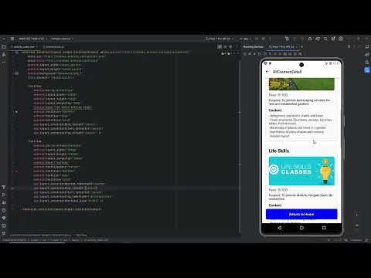](https://www.youtube.com/watch?app=desktop&v=c9CpavrqaHc)

[XHW 511](https://www.youtube.com/watch?v=2HRb7CE9fo0)

[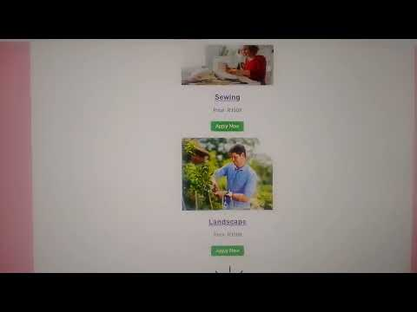](https://www.youtube.com/watch?v=2HRb7CE9fo0)

**ANNEXURE A**

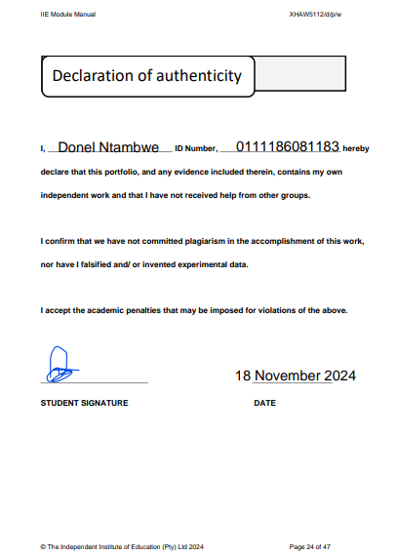

**ANNEXURE B – Peer Evaluation**

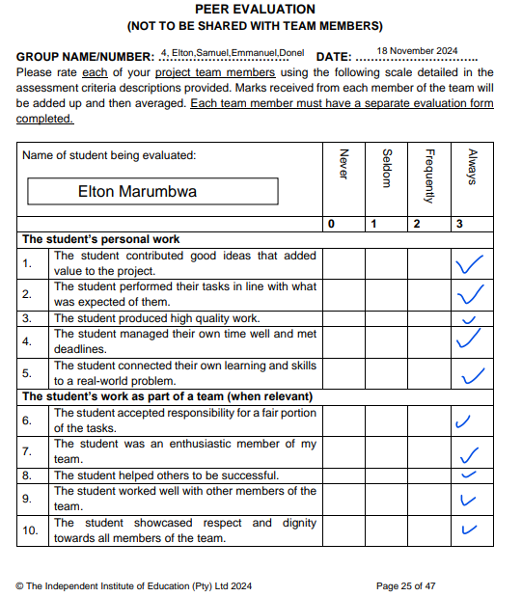

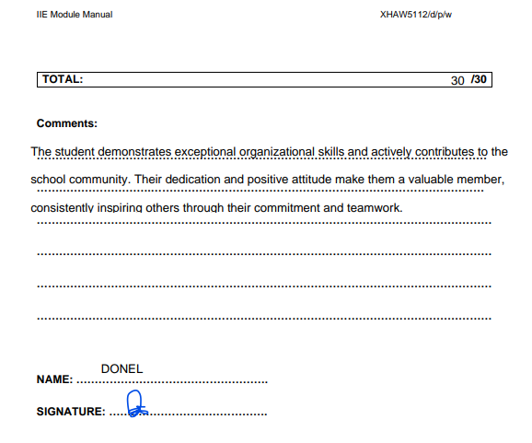

GitHub link

[Donel21/XHAW-GROUP-WORK-POE: this repository consists if all the final poe of XHAW and all the members names](https://github.com/Donel21/XHAW-GROUP-WORK-POE)